GARDEN CITY UNIVERSITY
DESIGN THINKING FOR SOFTWARE ENGINEERING
LAB - 2

NAME : SRADHANJALI SAHOO
SEM : 4TH , SEC : A
ROLL NO : 24BTCE126

APPOINTMENT BOOKING SYSTEMS LACK FLEXIBILITY

CONTEXT
  - APPOINTMENT BOOKING SYSTEMS ARE USED FOR HOSPITALS, GOVERNMENT OFFICES, BANKS, SALONS, AND UNIVERSITIES.
  - MOST SYSTEMS FOLLOW RIGID TIME SLOTS.
  - USERS OFTEN FACE DELAYS DUE TO TRAFFIC, WORK, OR EMERGENCIES.
  - MISSING A SLOT USUALLY LEADS TO CANCELLATION OR LONG WAITING TIMES.
  - RESCHEDULING IS OFTEN COMPLEX AND TIME-CONSUMING.
  - LACK OF FLEXIBILITY INCREASES USER FRUSTRATION AND NO-SHOWS.

STEP 1: DEFINE THE TARGET USER
TASK: IDENTIFY USERS OF APPOINTMENT BOOKING SYSTEMS.
TARGET USERS:
- AGE: 18–60 YEARS
- OCCUPATION: STUDENTS, WORKING PROFESSIONALS, GENERAL PUBLIC
- DEVICE: SMARTPHONE / LAPTOP
- DIGITAL LITERACY: MEDIUM TO HIGH
- SERVICES USED: HOSPITAL APPS, GOVERNMENT PORTALS, SERVICE BOOKING APPS

STEP 2: LIST INITIAL ASSUMPTIONS
TASK: WRITE ASSUMPTIONS BEFORE INTERACTING WITH USERS.
- APPOINTMENT SYSTEMS ARE TOO RIGID AND DO NOT ADAPT TO USER SCHEDULES.
- USERS ARE FORCED TO REBOOK FOR DELAYS OR RESCHEDULING EVEN WHEN SLOTS ARE AVAILABLE.
- URGENT CASES ARE NOT PRIORITIZED AND FOLLOW THE SAME PROCESS AS NORMAL BOOKINGS.
- POOR SYSTEM SUPPORT AND UPDATES WASTE USER TIME AND CAUSE CONFUSION.

ID | Assumption
A1 | Appointment booking systems are rigid and lack schedule flexibility.
A2 | Users must rebook appointments even for minor delays or changes.
A3 | Urgent cases are not given priority over normal appointments.
A4 | Poor system support and updates cause confusion and waste user time.

STEP 3: PREPARE INTERVIEW QUESTIONS
TASK:
DESIGN SIMPLE, OPEN-ENDED, NON-JUDGMENTAL QUESTIONS.

QUESTIONS:
- WHICH APPOINTMENT BOOKING SYSTEM OR APP DO YOU USE MOST OFTEN?
- HAVE YOU EVER FACED DIFFICULTY DUE TO FIXED TIME SLOTS? PLEASE EXPLAIN.
- WHAT HAPPENS WHEN YOU ARRIVE LATE FOR AN APPOINTMENT?
- HOW EASY OR DIFFICULT IS IT TO RESCHEDULE OR CANCEL AN APPOINTMENT?
- HAVE YOU EVER NEEDED URGENT OR SAME-DAY APPOINTMENTS? WHAT WAS YOUR EXPERIENCE?
- DO YOU FEEL APPOINTMENT DURATIONS MATCH YOUR ACTUAL NEEDS? WHY OR WHY NOT?
- HAVE YOU EXPERIENCED LONG WAITING TIMES DESPITE BOOKING AN APPOINTMENT?
- DOES THE SYSTEM PROVIDE REAL-TIME UPDATES ABOUT DELAYS OR CHANGES?
- HAVE YOU TRIED CONTACTING SUPPORT FOR BOOKING OR CHANGES? WAS IT HELPFUL?
- WHAT ONE FEATURE WOULD MAKE APPOINTMENT BOOKING MORE FLEXIBLE FOR YOU?

STEP 4: CONDUCT USER INTERVIEW
- USER APPEARED CONFIDENT AND FAMILIAR WHILE DESCRIBING THE UTS BOOKING PROCESS.
- SHOWED NO HESITATION WHILE EXPLAINING TICKET VALIDITY AND USAGE RULES.
- DISPLAYED A NEUTRAL FACIAL EXPRESSION, INDICATING NO MAJOR FRUSTRATION WITH THE SYSTEM.
- CLEARLY RECALLED USAGE DETAILS SUCH AS ONE-HOUR VALIDITY AND BOOKING JUST BEFORE TRAVEL.
- EXPRESSED A NEED FOR BETTER REAL-TIME TRAIN STATUS UPDATES, INDICATING A MINOR GAP IN THE SYSTEM.

EXACT USER QUOTES:
- “ I USE UTS TO BUY LOCAL TRAIN TICKETS.”
- “ USUALLY ONCE WE BUY THE TICKET OUR JOURNEY MUST COMMENCE WITHIN AN HOUR.”
- “YES, IT'S EASY TO BOOK.”
- “MORE FEATURES ON UPDATING CURRENT TRAIN STATUS WOULD BE HELPFUL.”

STEP 5: CREATE EMPATHY MAP

SAYS  •“I USE UTS TO BUY LOCAL TRAIN TICKETS.”  •“ONCE WE BUY THE TICKET, THE JOURNEY MUST START WITHIN ONE HOUR.”  •“IT’S EASY TO BOOK.”  •“MORE FEATURES FOR UPDATING THE CURRENT TRAIN STATUS WOULD BE HELPFUL.” | THINKS  •BOOKING SHOULD BE QUICK AND RELIABLE BEFORE TRAVEL.  •KNOWING TRAIN AVAILABILITY IN ADVANCE WOULD REDUCE UNCERTAINTY.  •REAL-TIME INFORMATION IS MORE IMPORTANT THAN EXTRA FEATURES
DOES  •BOOKS TICKETS SHORTLY BEFORE ENTERING THE STATION.  •PLANS TRAVEL WITHIN THE ONE-HOUR VALIDITY WINDOW.  •DOES NOT CONTACT CUSTOMER SUPPORT. | FEELS  •GENERALLY CONFIDENT USING THE SYSTEM.  •CALM DUE TO EASE OF BOOKING.  •SLIGHTLY CONCERNED ABOUT LACK OF REAL-TIME TRAIN UPDATES.

STEP 6: VALIDATE ASSUMPTIONS
Assumption | Validated? | Reason
A1: Appointment systems are rigid and lack flexibility | ❌ | UTS allows flexible travel within a one-hour window.
A2: Users are forced to rebook for minor delays | ❌ | User can travel anytime within ticket validity without rebooking.
A3: Urgent needs are not handled differently | ❌ | No urgency-based booking required for local train tickets.
A4: Poor updates cause confusion and time wastage | ✅ | User mentioned lack of real-time train status updates.

STEP 7: IDENTIFY USER INSIGHTS
- USERS VALUE FLEXIBLE USAGE WINDOWS MORE THAN STRICT TIME SLOTS
- SIMPLE AND FAST BOOKING BUILDS USER CONFIDENCE
- LACK OF REAL-TIME UPDATES CREATES UNCERTAINTY DURING TRAVEL
- RELIABILITY MATTERS MORE THAN ADVANCED FEATURES
❎ “USERS STRUGGLE WITH BOOKING TRAIN TICKETS”
✅ “USERS ARE COMFORTABLE BOOKING TICKETS BUT NEED BETTER REAL-TIME INFORMATION”

STEP 8: CREATE USER PERSONA
USER PERSONA:

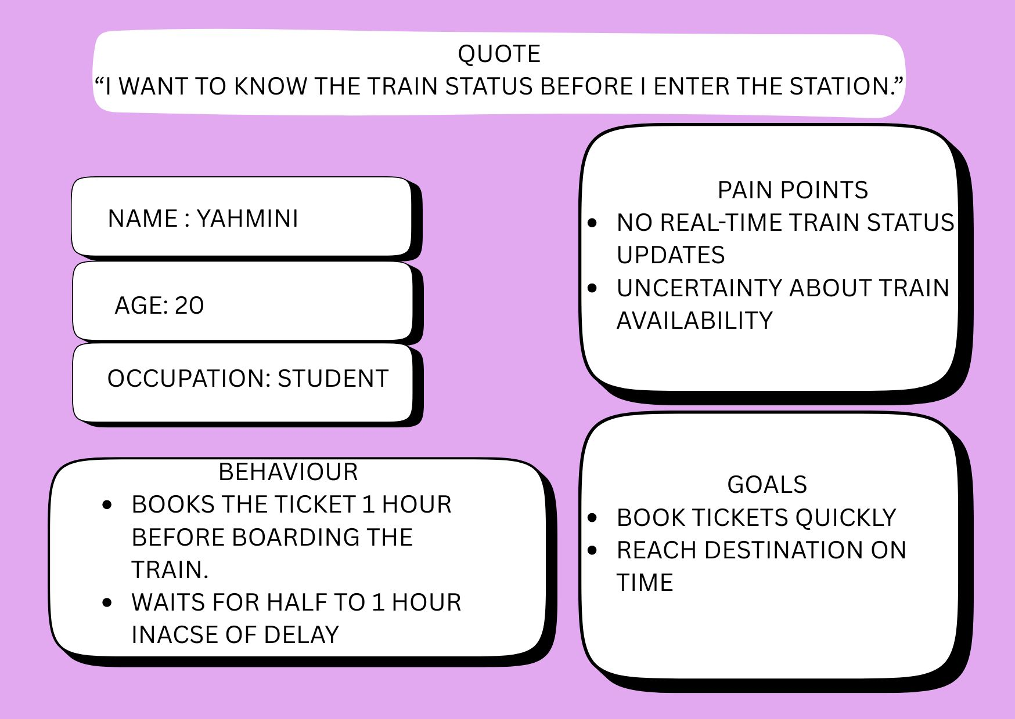

STEP 9: TRANSLATE INSIGHTS TO SOFTWARE NEEDS

User Insight | Software Requirement
Users rely on flexible ticket usage | Clear validity window display
Lack of real-time updates causes uncertainty | Live train status and delay updates
Users book tickets close to travel time | Quick-access booking feature
Reliability matters more than extra features | Accurate and timely system information

STEP 10: REFLECTION & DOCUMENTATION
- WHAT SURPRISED YOU DURING THE INTERVIEW?
→ I WAS SURPRISED THAT THE USER FOUND THE BOOKING PROCESS EASY AND FLEXIBLE.
- WHICH ASSUMPTION WAS WRONG?
→ MY ASSUMPTION THAT APPOINTMENT SYSTEMS ARE ALWAYS RIGID WAS PARTIALLY INCORRECT.
- HOW DID EMPATHY CHANGE YOUR THINKING?
→ USER INTERACTION HELPED ME UNDERSTAND THAT REAL-TIME UPDATES MATTER MORE THAN RESCHEDULING FEATURES IN THIS CASE.
- HOW WILL THIS AFFECT YOUR SOFTWARE DESIGN APPROACH?
→ THIS EXERCISE SHOWED ME THE IMPORTANCE OF DESIGNING SYSTEMS BASED ON REAL USER BEHAVIOR, NOT ASSUMPTIONS.

